Lesson 33

**Competencies**:

10.1.5 Students will understand practical considerations of reactor design including materials of construction, mixing, heat transfer, and economics.

Economics- p22

CSTR/Batch Reactors (2004)

|  |  |  |
| --- | --- | --- |
| Volume | Similar to: | Price |
| 5 Gallons | Wastebasket | $29,000 |
| 50 Gallons | Garbage can | $38,000 |
| 500 Gallons | Jacuzzi | $70,000 |
| 1000 Gallons | 2 Jacuzzis | $85,000 |
| 4000 Gallons | Swimming Pool | $150,000 |
| 8000 Gallons | Gasoline Tanker | $280,000 |

What about heating and mixing issues?

Mixing

Not all CSTRs are ideally mixed. This can lead to runaway reaction problems.

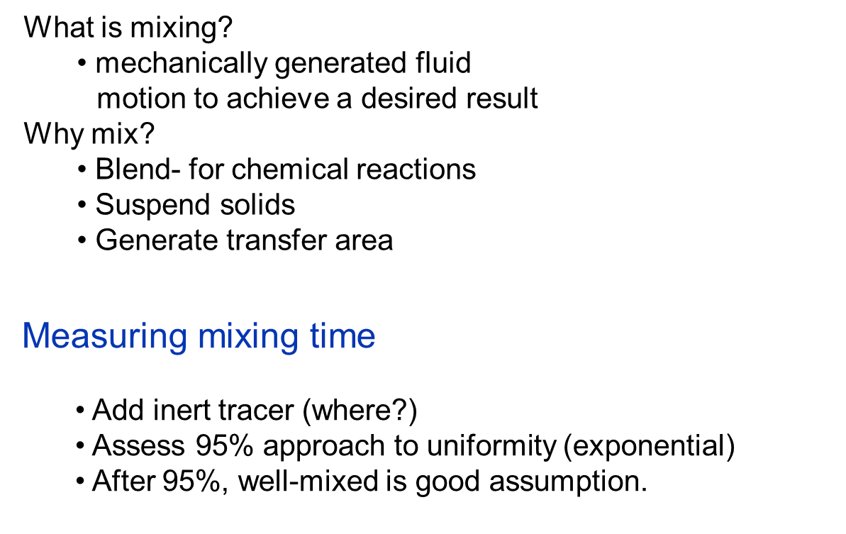

[Mixing time video demonstration](http://www.youtube.com/watch?v=oWiq0cw7By8)

[NaOH reaction with HCl video](http://www.youtube.com/watch?v=RvjklXPzxcc)

* Top tank- HCl
* Middle tank- NaOH
* Bottom tank- NaCl

Mixing versus reaction time:

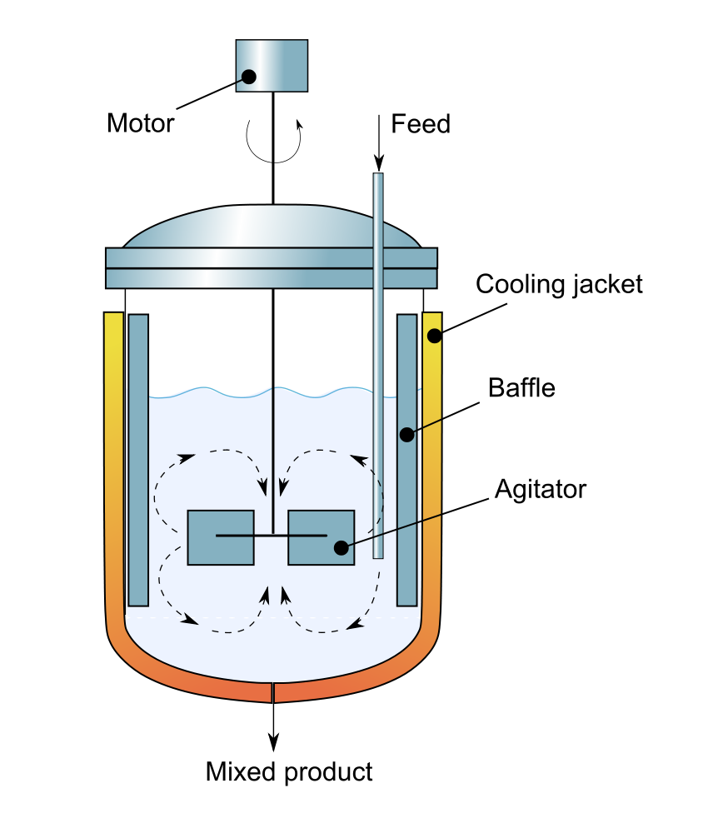

Mixing time (95%) ≈ (20 to 50)/ N

Reaction time ≈ 1/k for 1st order

Space time () = VR/*v0*

CSTR well-mixed assumption valid if:

*  >> mix time
* 1/k >> mix time

Mixing versus reaction

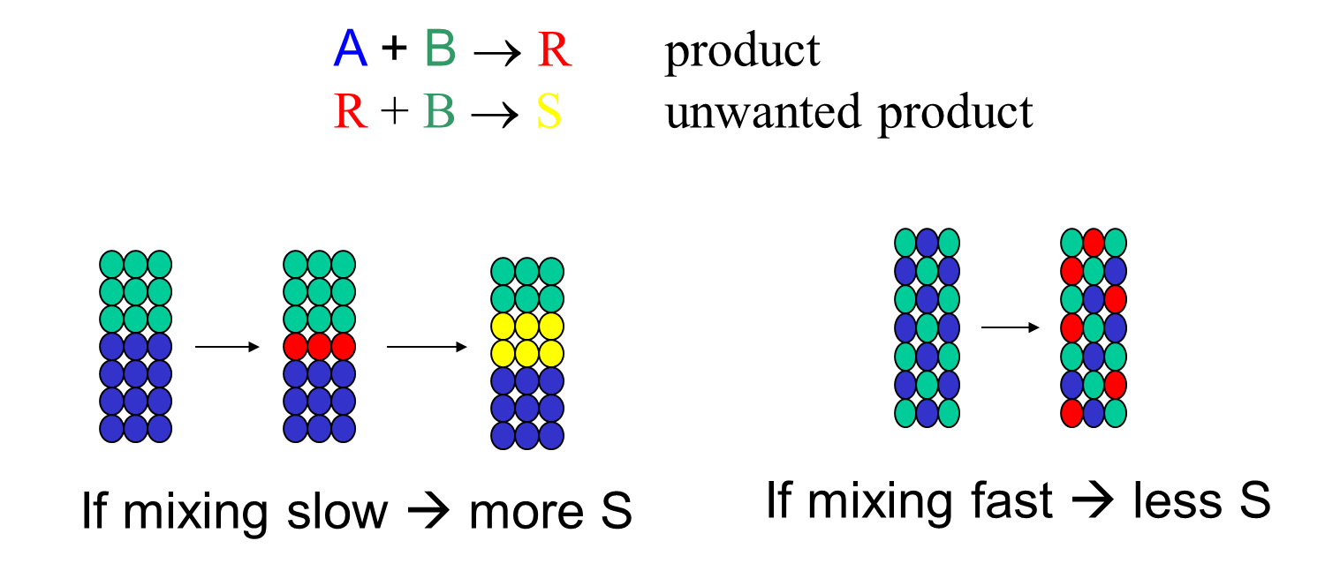

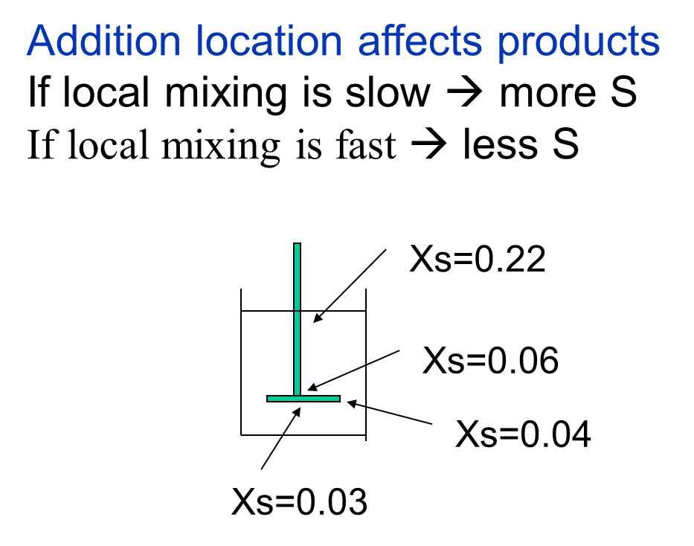

Mixing Simulation

Probe locations PA, PB, PC, PD, PE

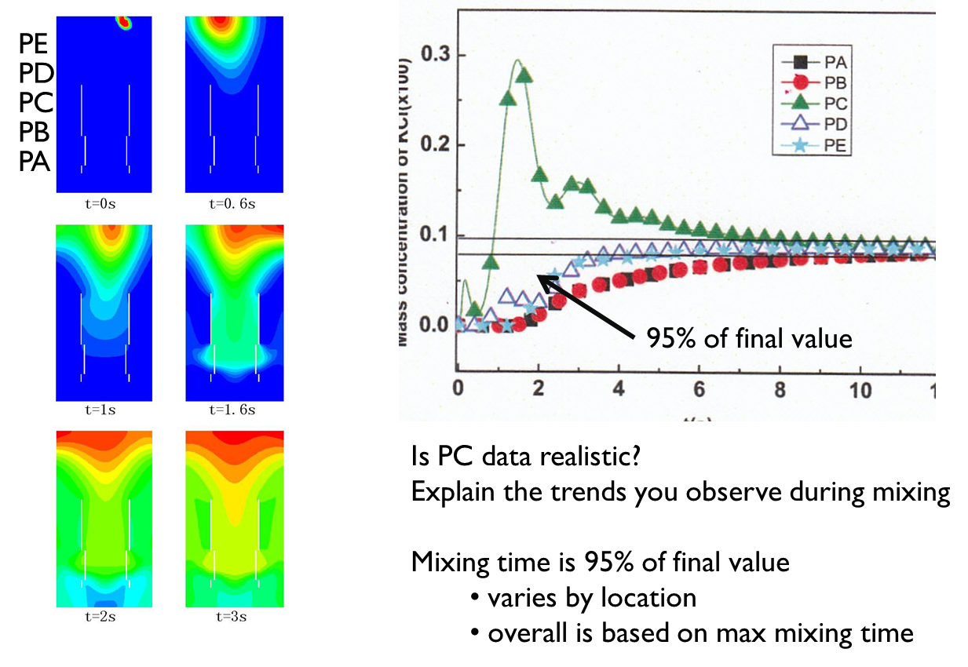

Scale-up

* As size increases, mixing takes longer.
* Mixing affects only fast reactions.
* Reaction may be masked by mixing time.

S= scale-up B= base case NP= power number

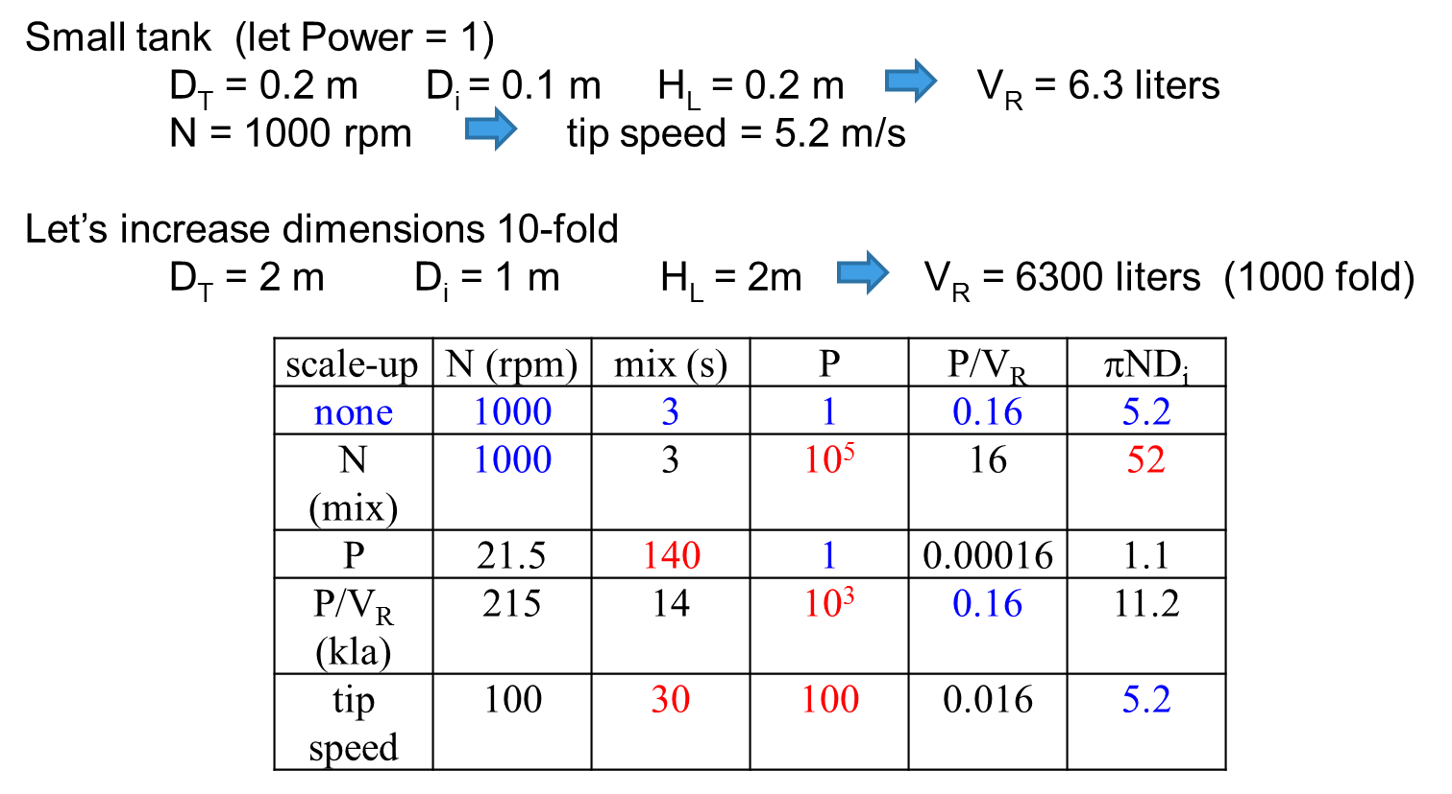

N: related to mixing time; tip speed

P: energy required to stir

P/VR: proportional to mass transfer (or heat)

Tip speed: affects particles or cells (shear)

Summary

* Be careful of mixing time versus reaction time- kinetics can be masked
* You can have large concentration gradients depending upon stirrer
* Scale-up doesn’t keep all parameters the same- What is important?
* Stirrer design can make a difference
  + [Silverson mixer video](http://www.youtube.com/watch?v=9dpMdby3ZY0)